GeodIS Page

Logo_PUMA2Tibco Developer Starting Guide

|  | **Name / Project Role** | **Signature** | **Date (DD/MM/YYYY)** |
| --- | --- | --- | --- |
| **Author** | Julien BARON | | 27/07/2017 |
| **Approver** |  | |  |

Distribution List

| **Names & Department** | **Rationale** |
| --- | --- |
|  |  |

Version History

|  |  |  |
| --- | --- | --- |
| **Version** | **Date (DD/MM/YYYY)** | **Modification** |
| 1.0 | 27/07/2017 | Document creation |

Table of contents

[1. Introduction 5](#_Toc491702424)

[2. Git configuration 5](#_Toc491702425)

[3. Framework installation 10](#_Toc491702426)

[4. Working with Working Sets 20](#_Toc491702427)

[5. Maven launchers 22](#_Toc491702428)

[6. Local EMS 27](#_Toc491702429)

[7. EMS drivers 29](#_Toc491702430)

[8. Disable Java updates 30](#_Toc491702431)

[9. ESB Audit plugin for runtime 32](#_Toc491702432)

[10. Hotfix TIB bwpluginsap 8.1.1 engineering build002 to fix the iDOC bug 33](#_Toc491702433)

# Introduction

This document content presents the first steps a Business Works 6 developper must do to have a ready to develop environment.

The prerequisites are is to have :

* a VDI with BW 6.4 Developer package deployed on it.
* a Gitlab account to retrieve Tibco framework

# Git configuration

First we will create the folder that will be used to retrieve sources in **c:\tibco\git**

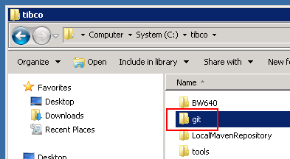

Then we will launch Tibco Designer, go to **Start Menu 🡪Tibco 🡪 …. 🡪 Studio for Designers**

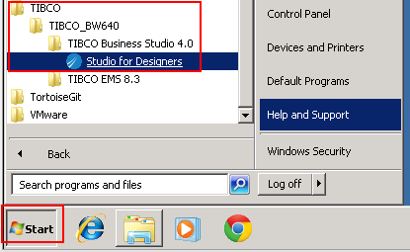

Go to **Window 🡪 Preferences**

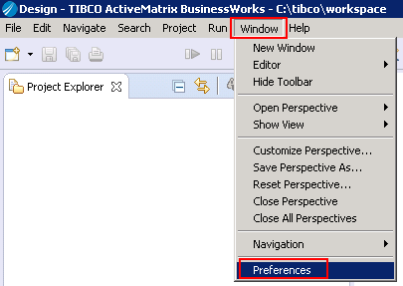

Filter configuration to reach **Git** configuration, click on **Browse**

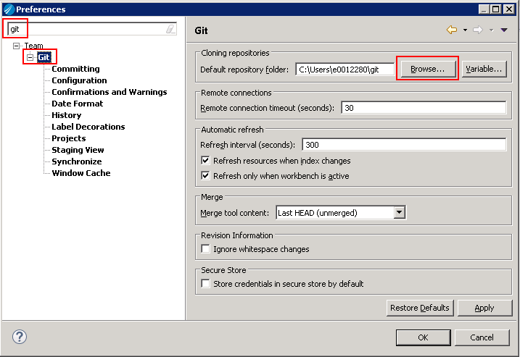

Select **C:\tibco\git** and click on **OK**

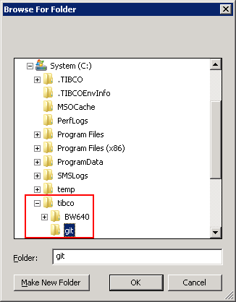

You should have following display

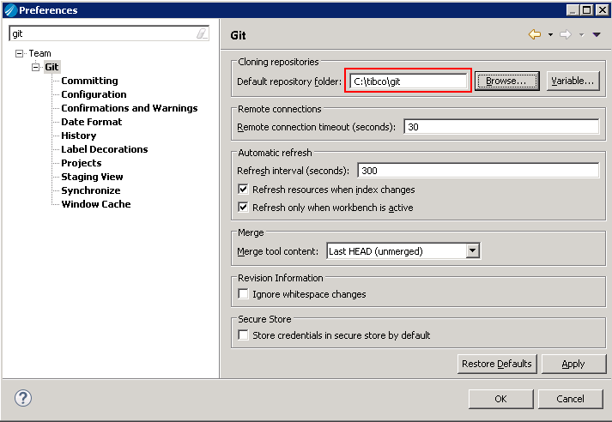

Then select **Git** **Configuration** and click on **Add Entry** in **User Settings** tab

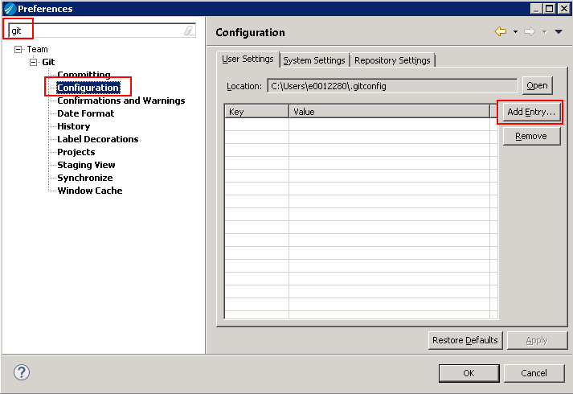

Fill **Key/Value** with **http.sslVerify** and **false**, then click on **OK**

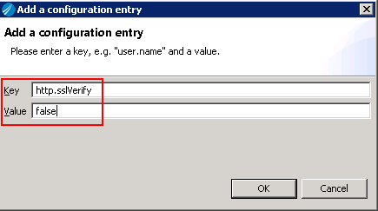

You should obtain following display, quit by clicking on **OK**

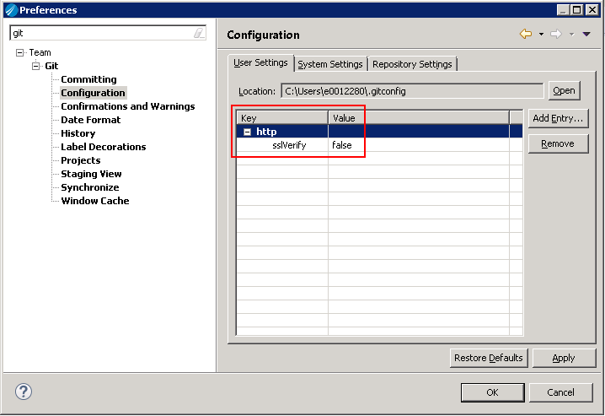

Click on **OK** to close the window. Then click on the upper right corner to display **Git** perspective

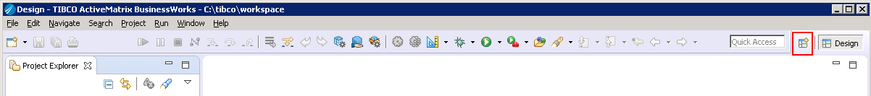

Choose **Git** and click on **OK** to close

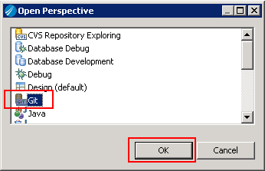

# Framework installation

Open a browser and navigate to following URL (which is framework Git repository):

<https://gitlab-its.sanofi.com/tibco/platform/BW640/tibco-frk/source/framework>

Enter your Git credentials that are your Windows account (Active directory)

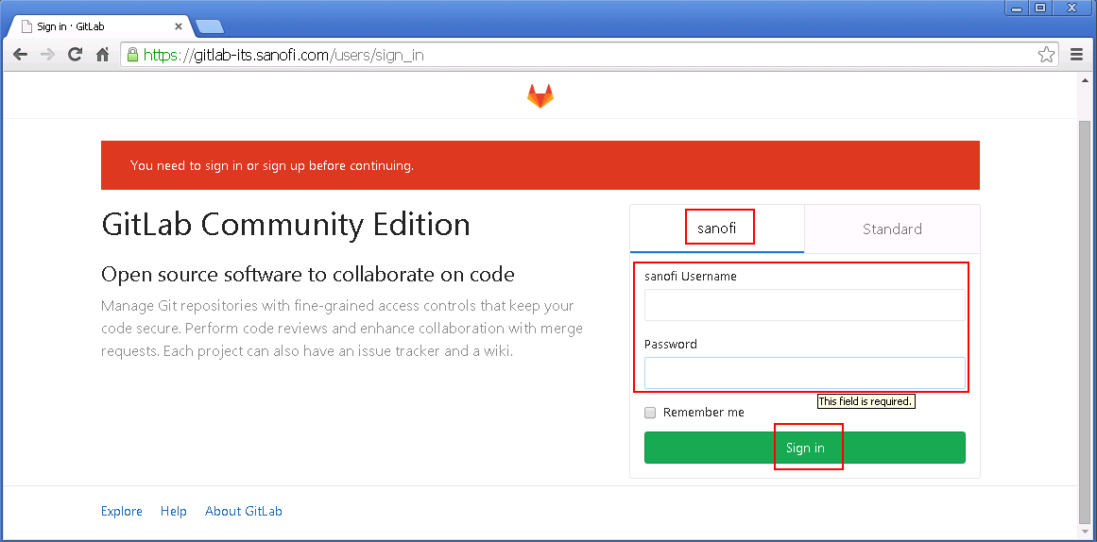

Choose **HTTPS** instead of SSH and copy the URL in the clipboard

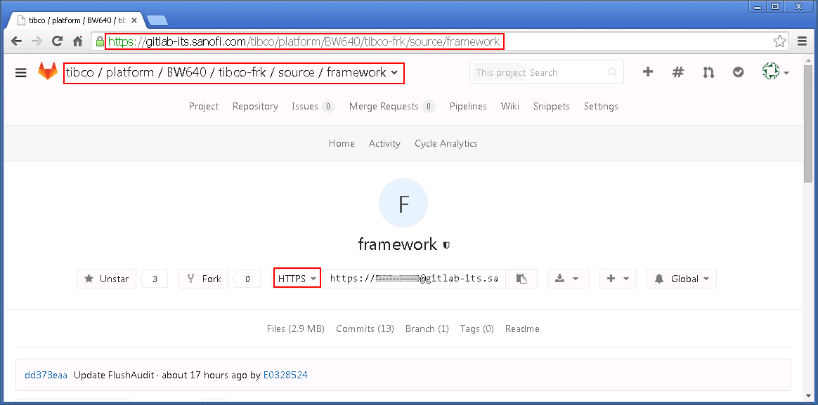

In **Business Studio Designer**, choose **Git** perspective (button at the upper right corner) and then, click on the **Clone a git repository** link

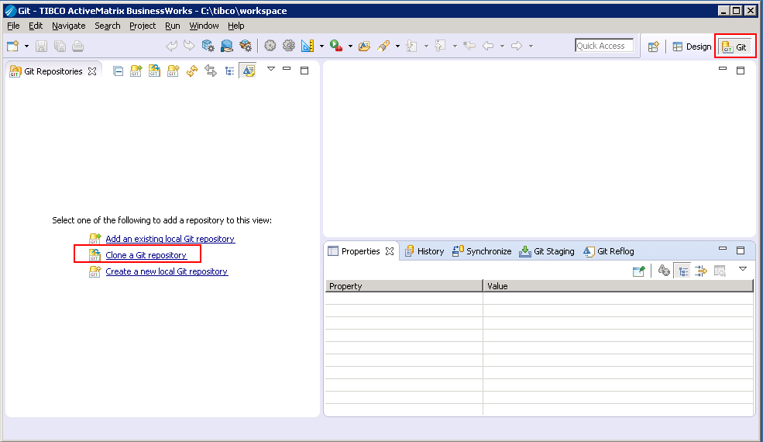

The following window is presented to you, all repository information is pre-filled, you’ll have to complete with your **Git** password and then click on **Next**

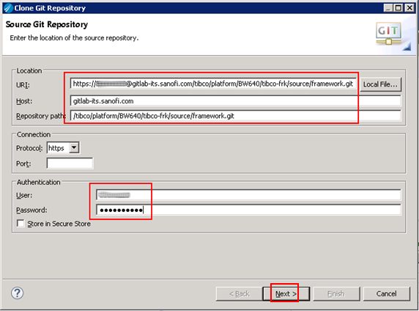

Select **master** and click on **Next**

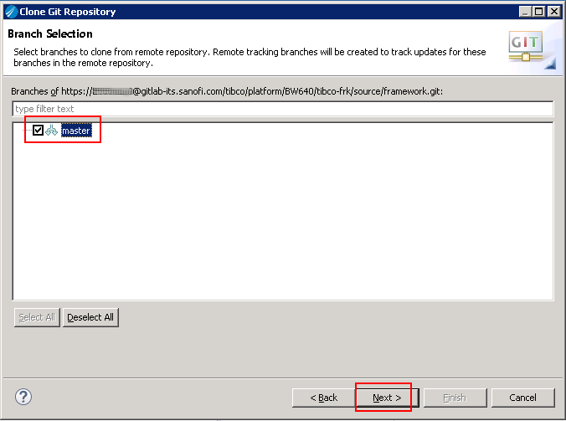

**Directory** should be accurate, check **Import all existing…** and  **Add project to…** checkboxes and click on **Select**

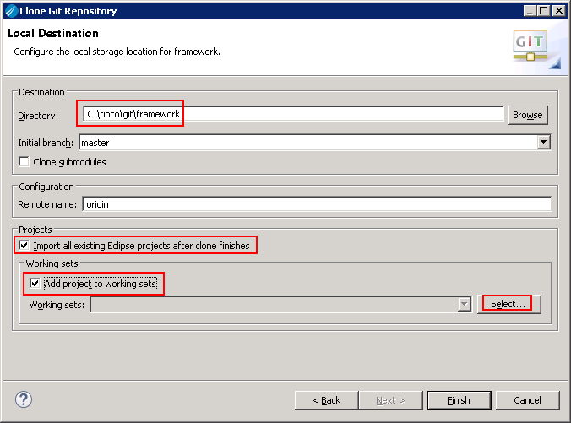

Click on **New**

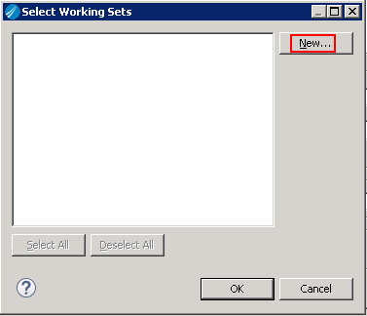

Select **Resource** and click on **Next**

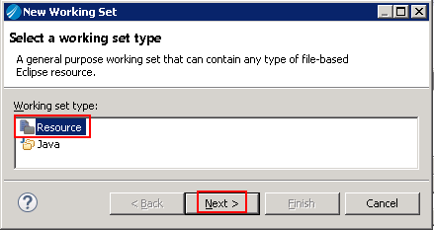

Name it **Framework** and click on **Finish**

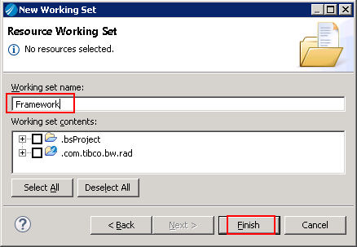

Select **Framework** and click on **OK**

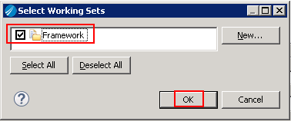

Click on **Finish**

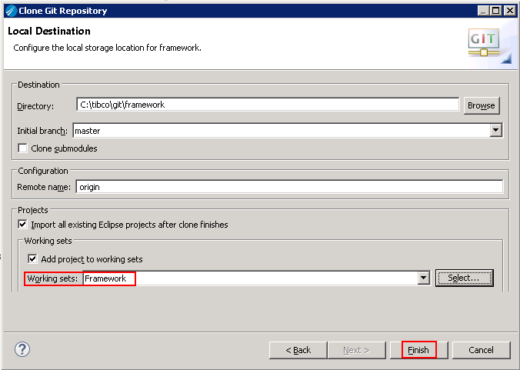

You should have the following display, click on **Design** button :

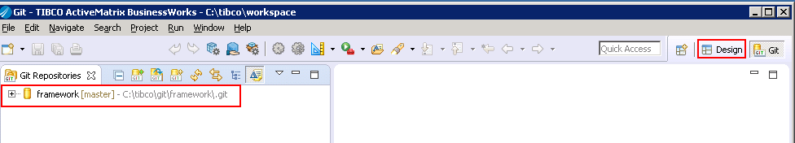

Let’s wait a bit while projects are compiling, at the end of the compilation you should have some errors, it is **normal ☺**

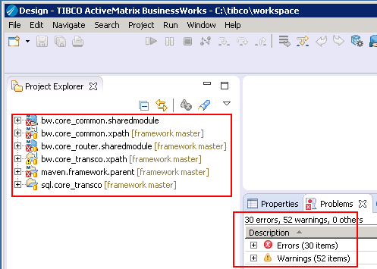

Select **bw.core\_common.xpath** project, right click on it and choose **Export 🡪 Export**

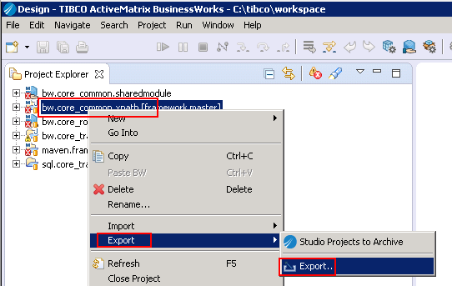

Select **Deployable plug-ins and fragments** and click on **Next**

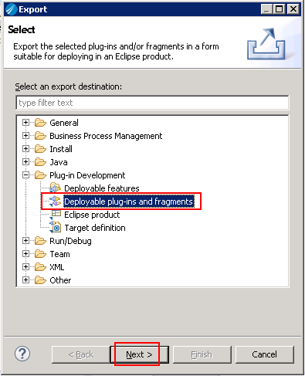

Ensure that only **bw.core\_common.xpath** is selected, select **Install into host…** and click on **Finish**

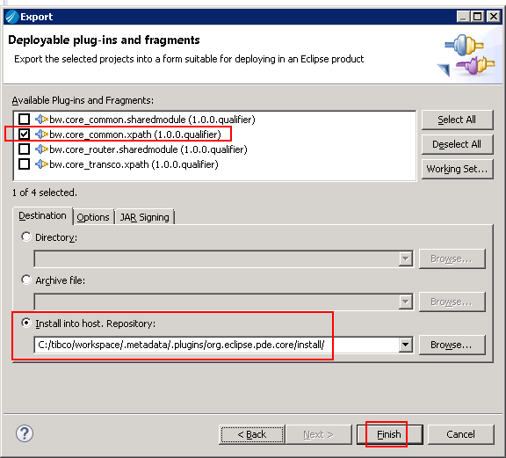

Click on **OK**

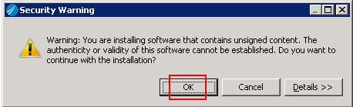

Click on **Yes** and wait for Business Studio to be restarted

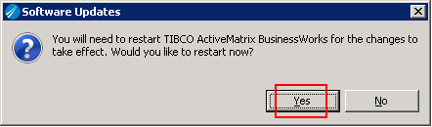

Select only the followings projects and right-click on them, then selec **Refactor 🡪 Repair BusinessWorks Projects…**

* bw.core\_common.sharedmodule
* bw.core\_router.sharedmodule

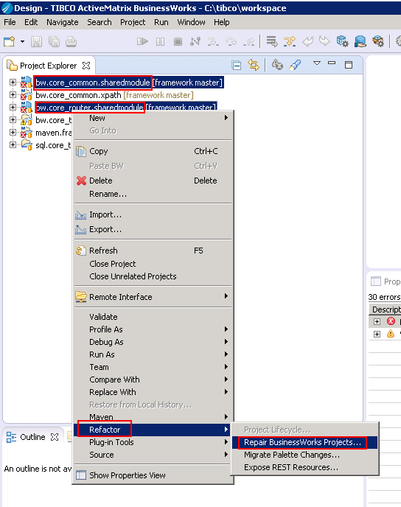

Ensure that the two same projects are selected and click on **OK**

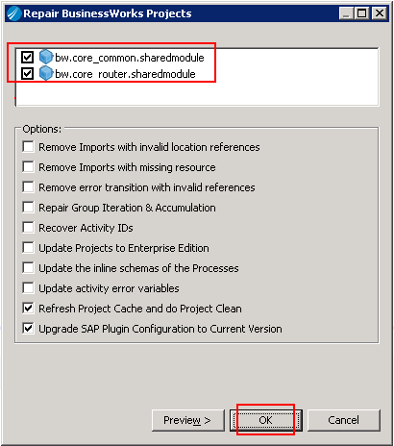

Let’s wait a bit while projects are compiling, at the end of the compilation you should have remaining errors, the one with **Special folders missing** can be resolved by right-clicking on it and select **Quick Fix**

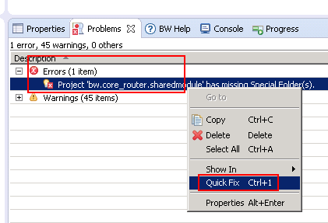

Click on **Finish**

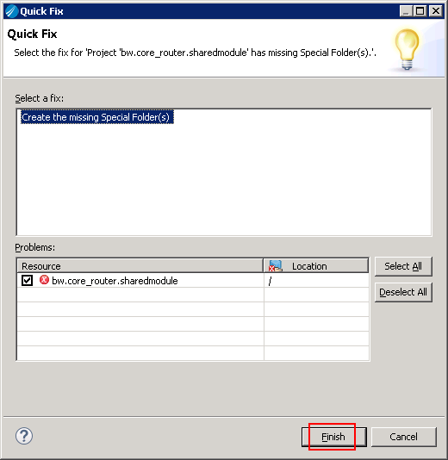

You should obtain only warnings as followed:

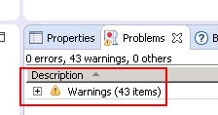

# Working with Working Sets

Working sets is an eclipse feature allowing you to group related projects into a sort of folder. We will use this feature to group frameworks projects.

Select the arrow button below and select **Top Levels Elements 🡪 Working Sets**

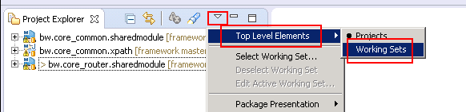

Select the arrow button below and select **Select Working Set**

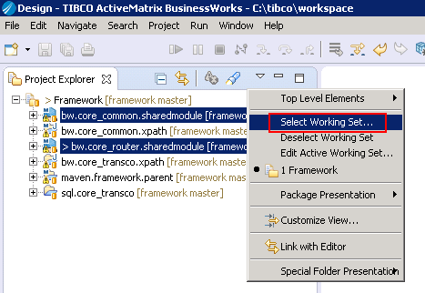

Select **Selected Working Sets** and choose **Framework** then click on OK

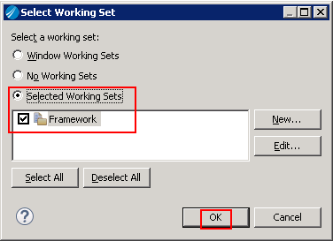

You should obtain following display

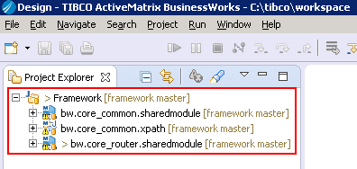

You are now ready to develop

# Maven launchers

Open a browser and navigate to following URL:

<https://gitlab-its.sanofi.com/tibco/platform/BW640/tibco-frk/scm/tools>

Enter your Git credentials that are your Windows account (Active directory)



Choose **HTTPS** instead of SSH and copy the URL in the clipboard



In **Business Studio Designer**, choose **Git** perspective (button at the upper right corner) and then, click on the **Clone a git repository** link



The following window is presented to you, all repository information is pre-filled, you’ll have to complete with your **Git** password and then click on **Next**

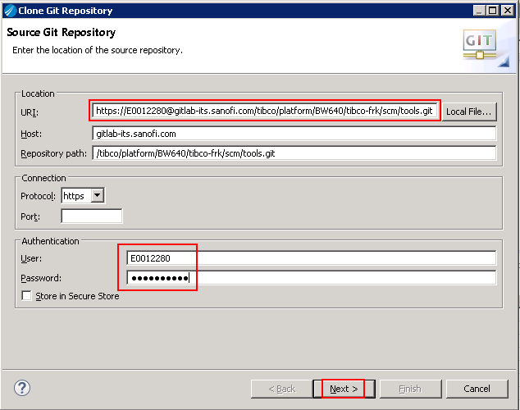

Select **Master** and click on **Next**

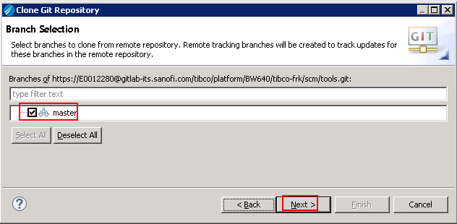

Check **Import all existing….** And **Add project to…** checkboxes, ensure that **Working sets** is **Framework**, then click on **Finish**

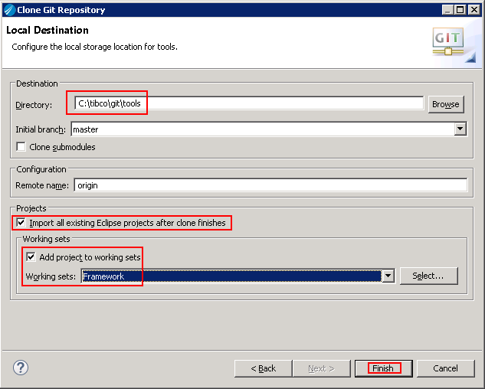

In **Design** view right-click on **studio-maven-launchers** project and choose **Import > Import…**

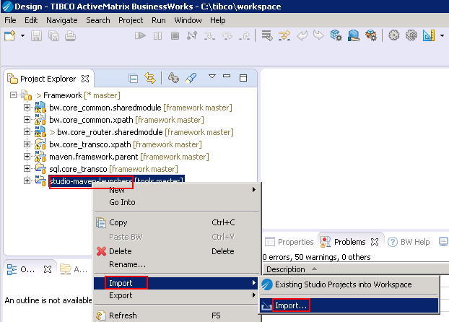

Choose **Run/Debug** > **Launch Configurations** and click on **Next**

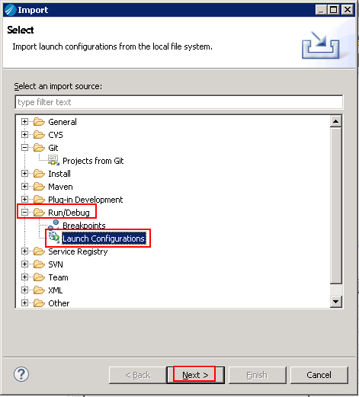

Choose only **03 – Deploy** and click on **Finish**

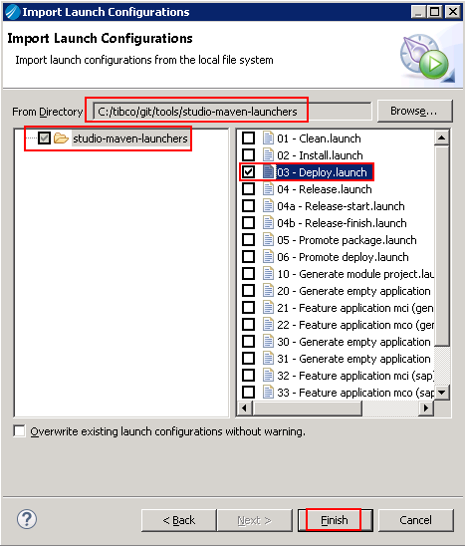

Right-click on **studio-maven-launchers** project and choose **Close project**

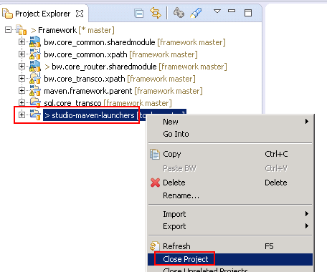

You should have only this display.

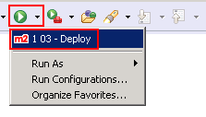

# Local EMS

To launch a local EMS on your machine, launch **Start Menu > TIBCO > TIBCO EMS 8.3 >Start EMS Server**

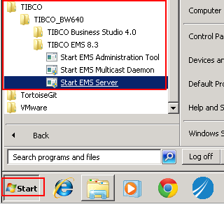

You should have following display:

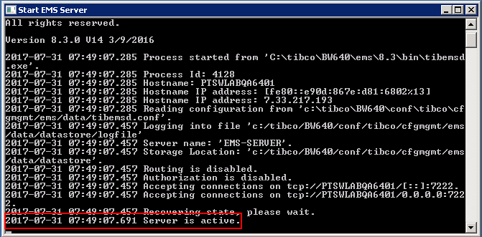

To connect to the EMS, go to **c:\tibco**\tools and launch **GEMS** tool

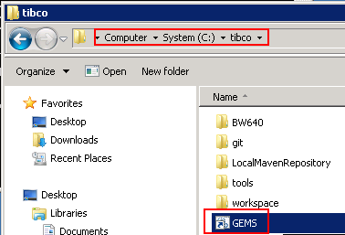

If the EMS is started you should have following display:

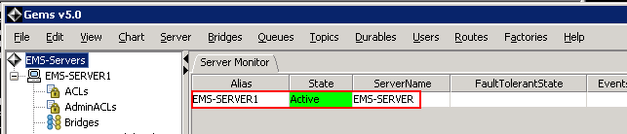

In Queues**, ensure that you have a > queue** (which allow dynamic queue creation)

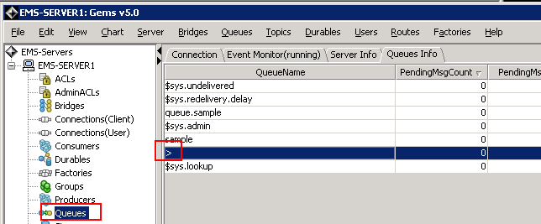

In Topics**, ensure that you have a > topic** (which allow dynamic topic creation)

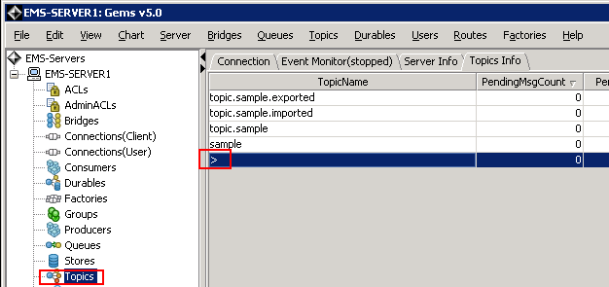

If you want to add another EMS server, configuration is located in **c:\tibco\tools\Gems\server.xml**

Configure **alias**, **url**, **user** and **password**

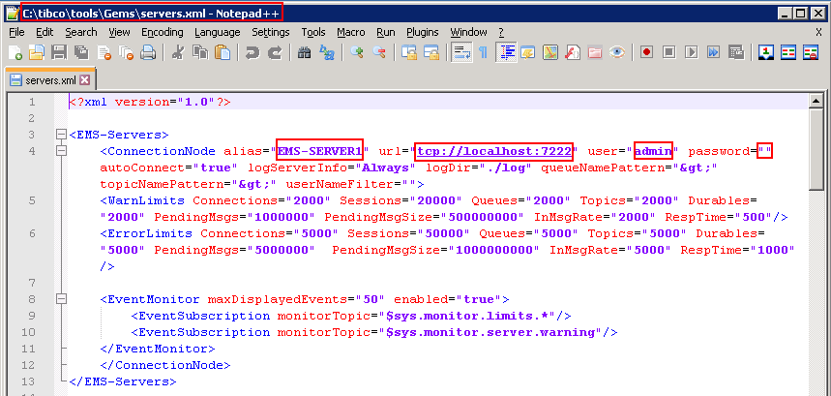

# EMS drivers

We will add EMS drivers to your Designer installation. In order to do this, follow the steps below:

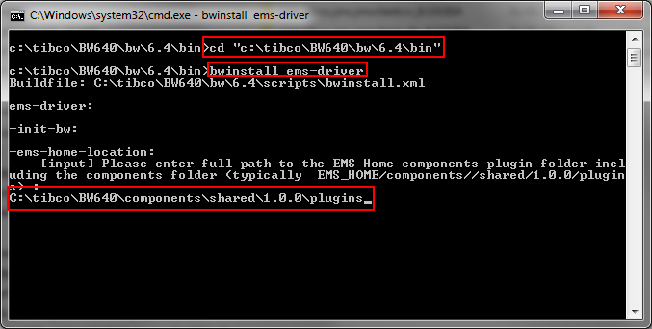

Open **command line prompt**  
Type **cd C:\tibco\BW640\bw\6.4\bin**Then : **bwinstall ems-driver**Then : **C:\tibco\BW640\components\shared\1.0.0\plugins**

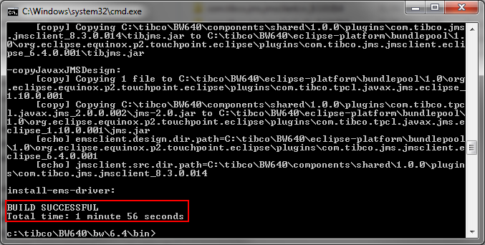

Check that **BUILD IS SUCCESSFUL** is displayed

# Disable Java updates

In order to not break Tibco installation and for everyone to have exactly the same workstation we will disable Java updates, to do so follow the steps below

In start menu, select **Java > Check For Updates**

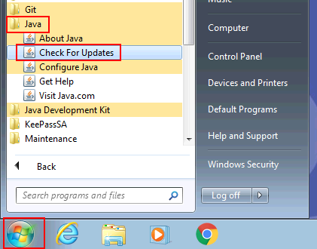

Unckeck **Check for Updates Automatically** and confirm with **Do Not Check**  button

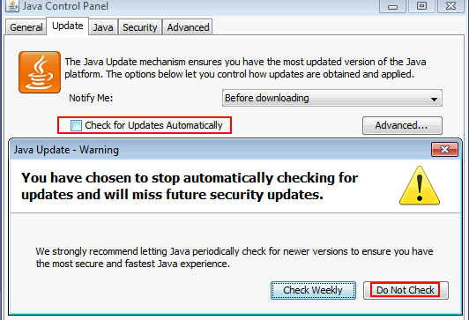

Do not forget to **Apply**

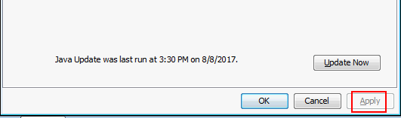

# ESB Audit plugin for runtime

We will add ESB Audit plugin for runtime, first **close** Business Studio Designer.

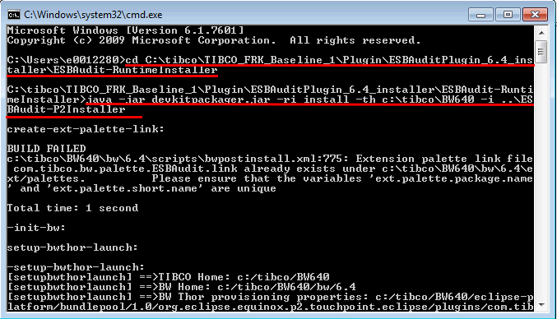

Open **command line prompt**  
Type **cd C:\tibco\TIBCO\_FRK\_Baseline\_1\Plugin\ESBAuditPlugin\_6.4\_installer\ESBAudit-RuntimeInstaller**Then : **java -jar devkitpackager.jar -ri install -th c:\tibco\BW640 -i ..\ESBAudit-P2Installer**

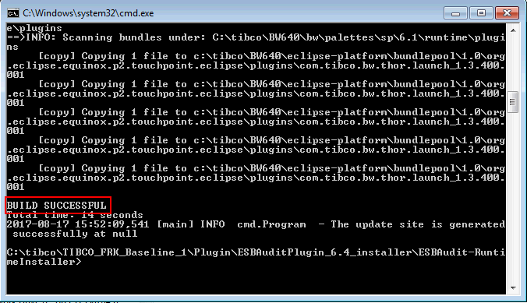

Check that **BUILD** is **SUCCESSFUL**

# Hotfix TIB bwpluginsap 8.1.1 engineering build002 to fix the iDOC bug

The engineering build only includes a design time jar file for the plugin palettes. Installing the SAP plugin requires the provision of SAP libraries separately and to be referenced in the Universal Installer.

1. On your VDI, create a directory named Packages :

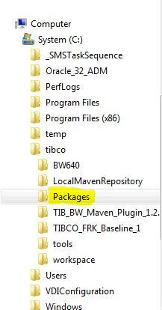

1. On IE new Tab, specify the URL: [http://wssemea.sanofi.com/ws/IntSRV/packages/Forms/AllItems.aspx](https://teams.collab.sanofi.com/ws/IntSRV/packages/Forms/AllItems.aspx) where you find two packages :
   1. TIB\_bwpluginsap\_8.1.1\_engineering\_build002.zip
   2. sapjco\_x64New.zip

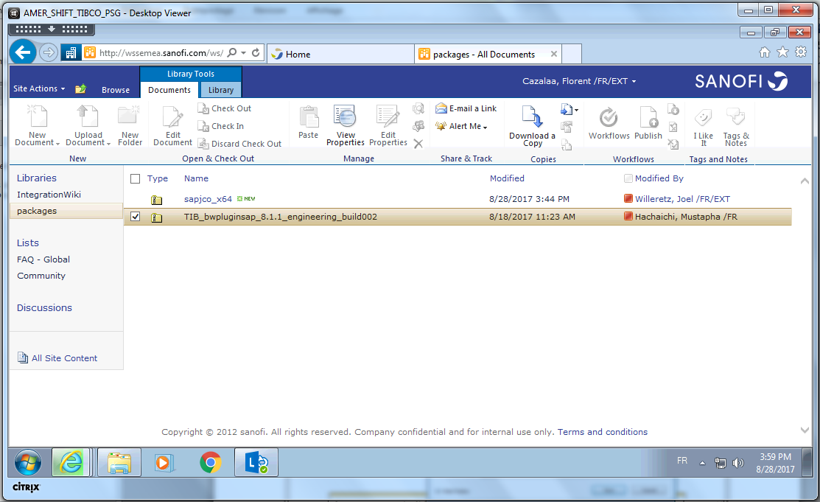

1. Click on the **TIB\_bwpluginsap\_8.1.1\_engineering\_build002.zip** to download it in the Packages directory

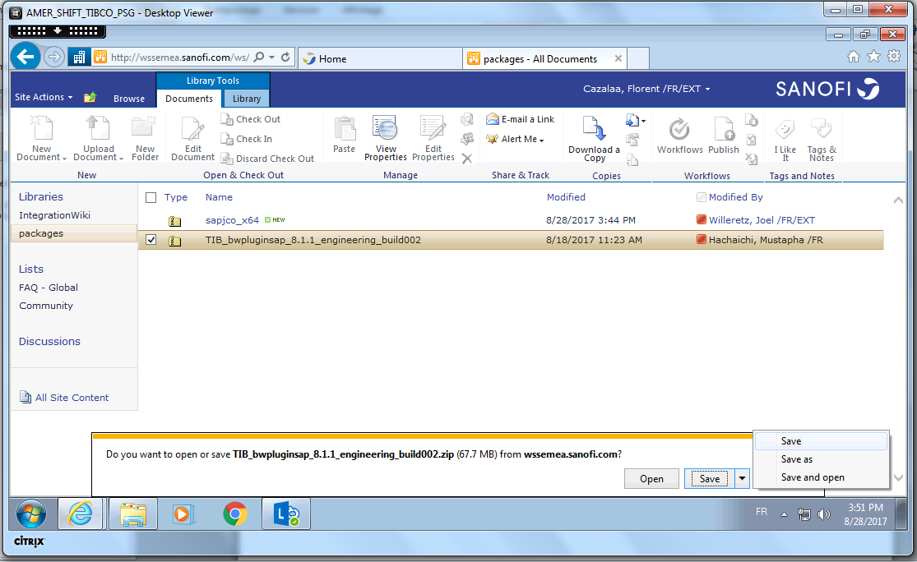

1. Do the same with **sapjco\_x64New.zip**

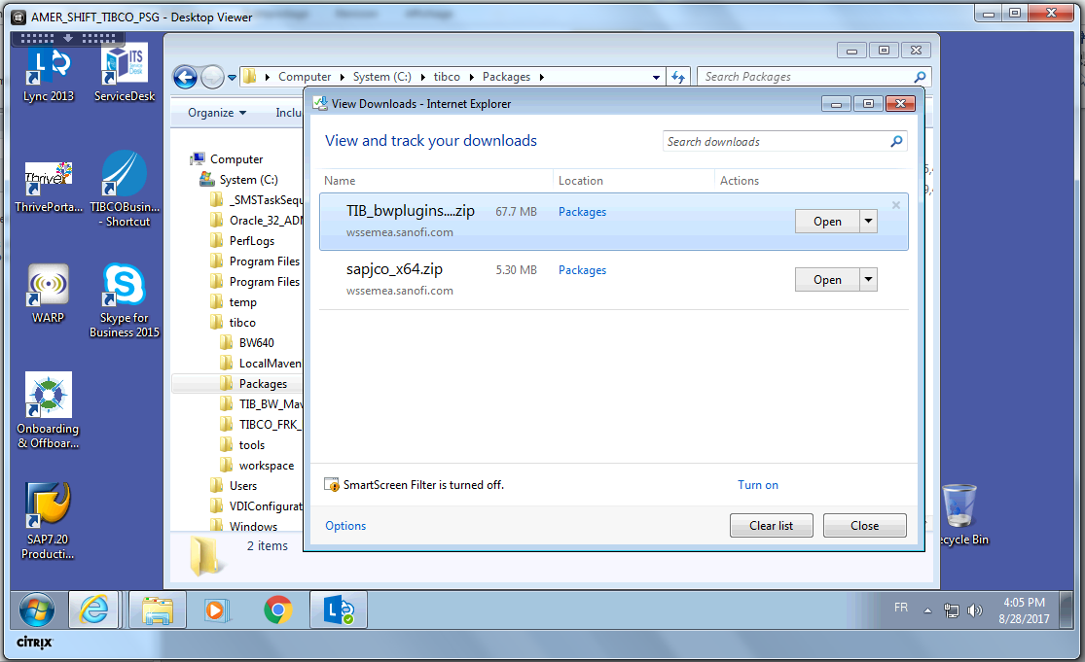

1. When the downloads are completed, you must have the two ZIP files in Package directory, then Unzip both of them in the same directory.

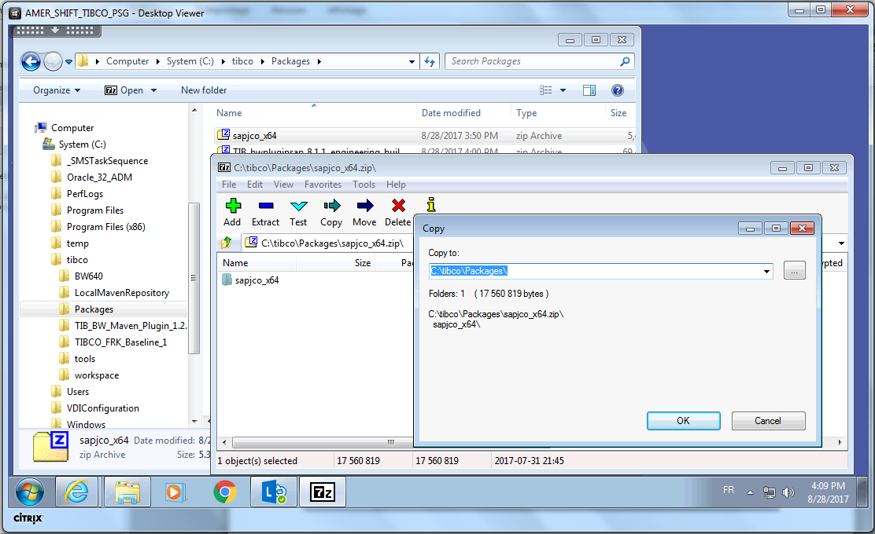

1. Double-Click on the directory TIB\_bwpluginsap\_8.1.1\_engineering\_build002 up to you arrive on the sub-directory: C:\tibco\Packages\TIB\_bwpluginsap\_8.1.1\_engineering\_build002\TIB\_bwpluginsap\_8.1.1\_engineering\_build002

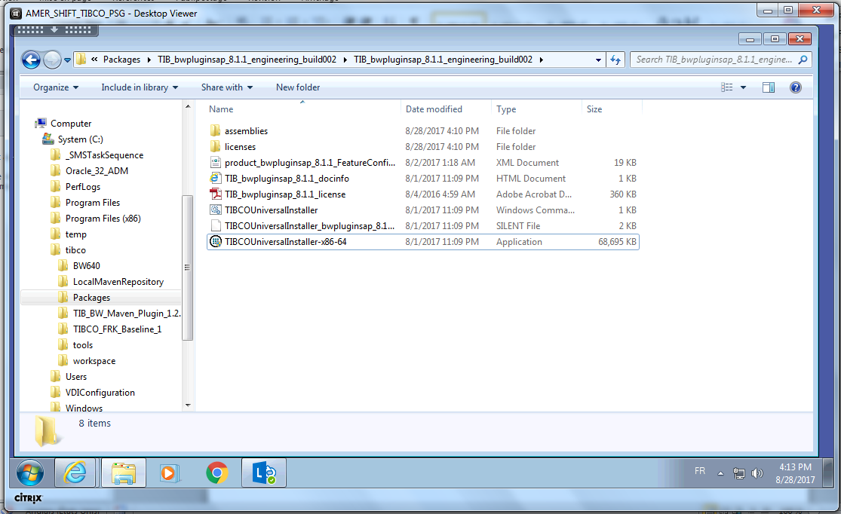

1. Launch the Universal Installer

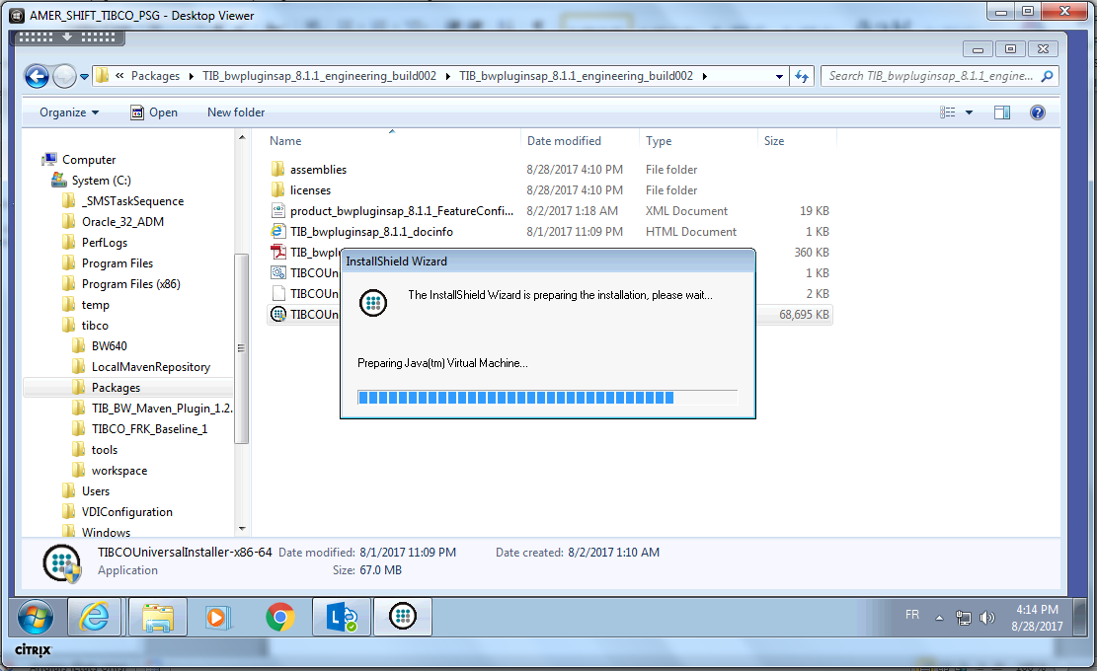

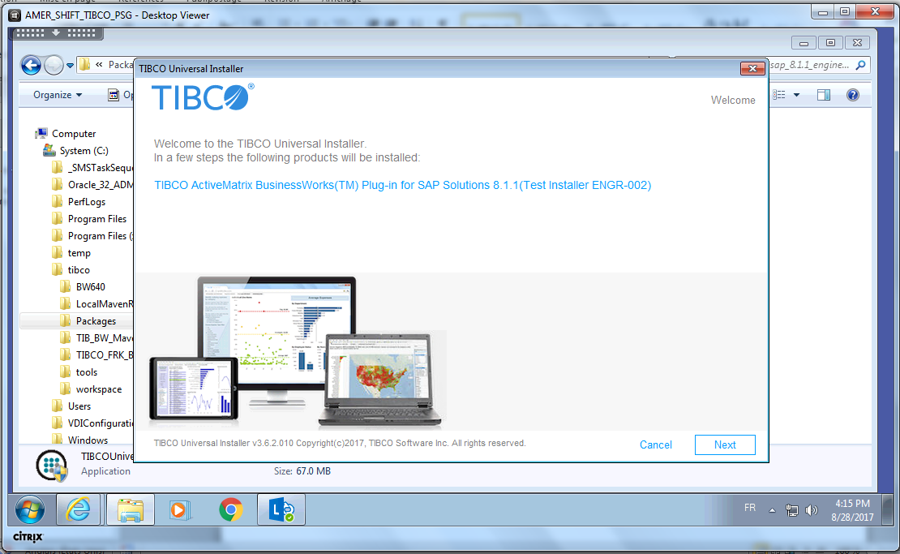

1. Accept the term of license agreement, then press Next button

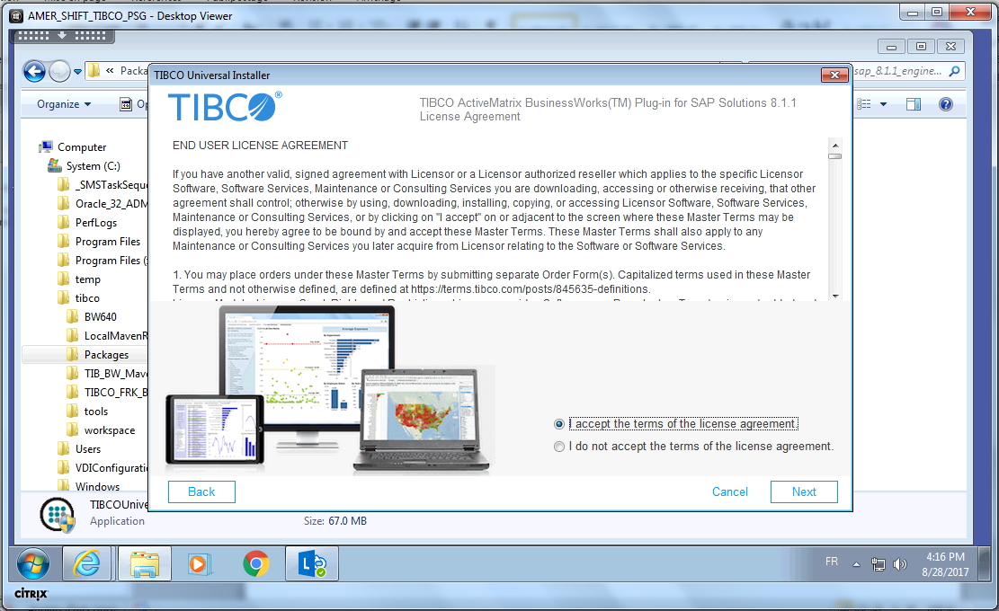

1. Use an existing TIBCO Home

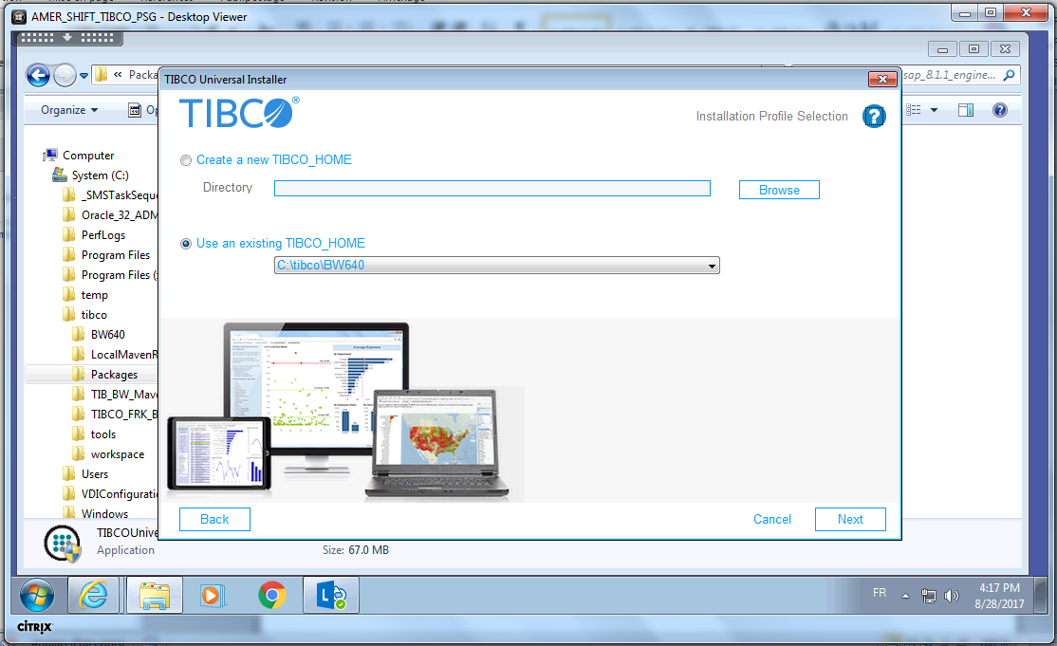

1. Typical installation, then press Next button

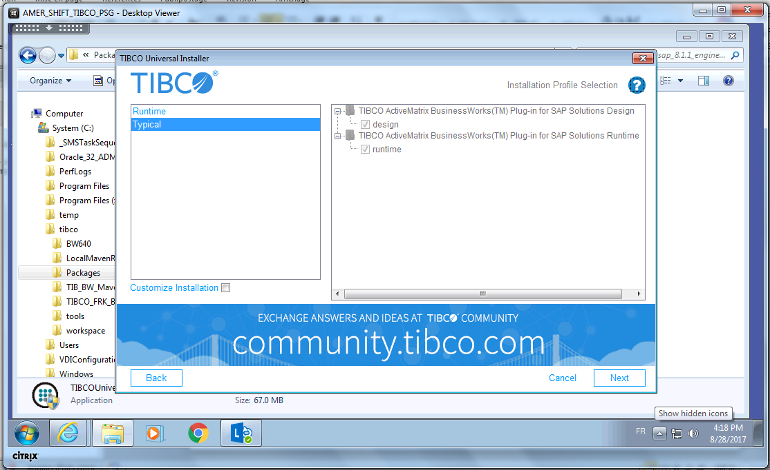

1. Select **YES button** to reinstall the SAP JCO libraries

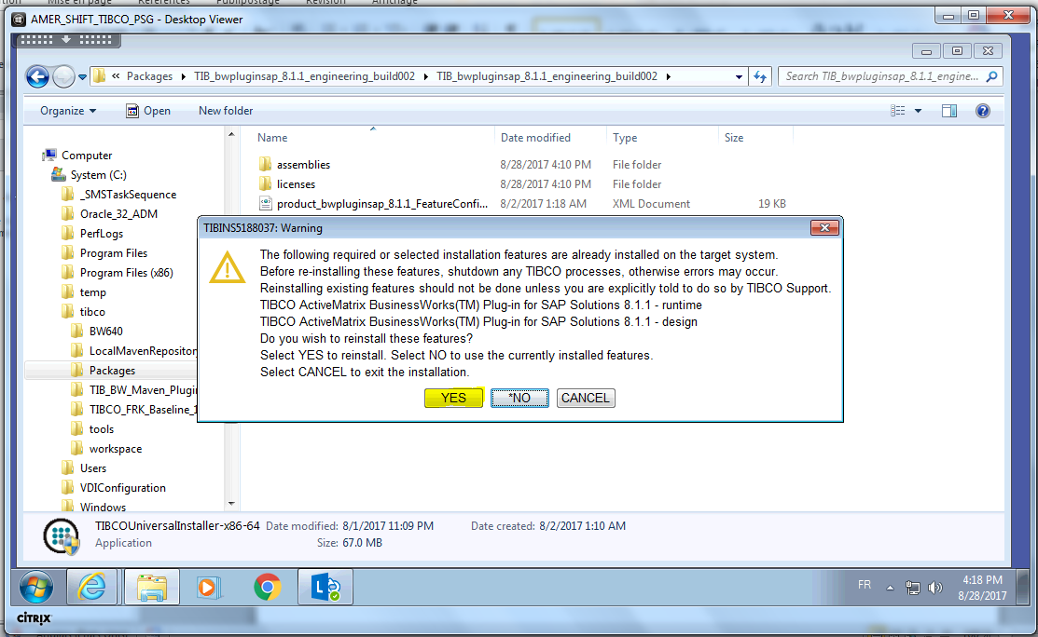

1. Specify the location of SAP JCo librairies 🡪 **C:\tibco\Packages\sapjco\_x64**

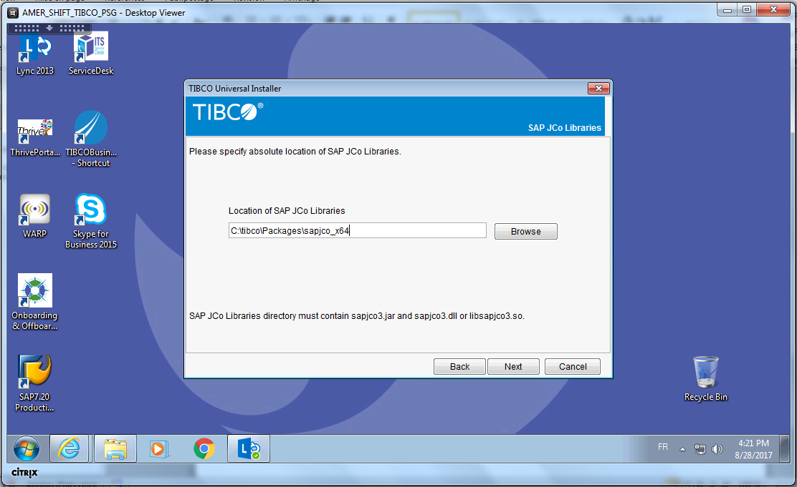

1. Click on Next button to start the installation of the Hotfix

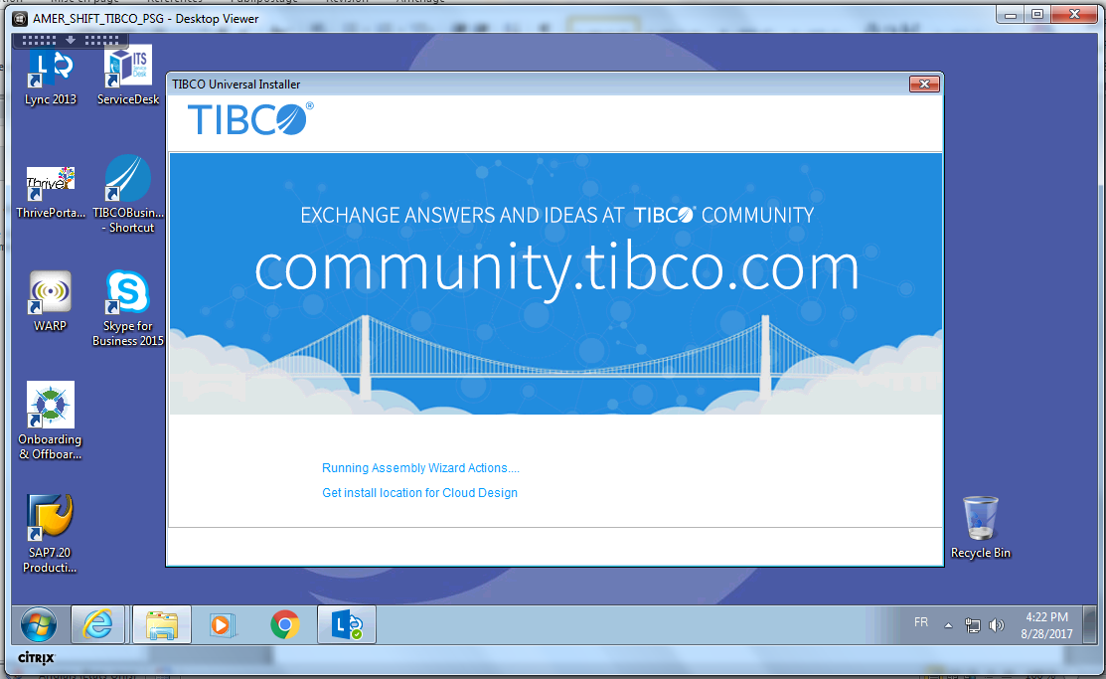

Pre-installtion Summary

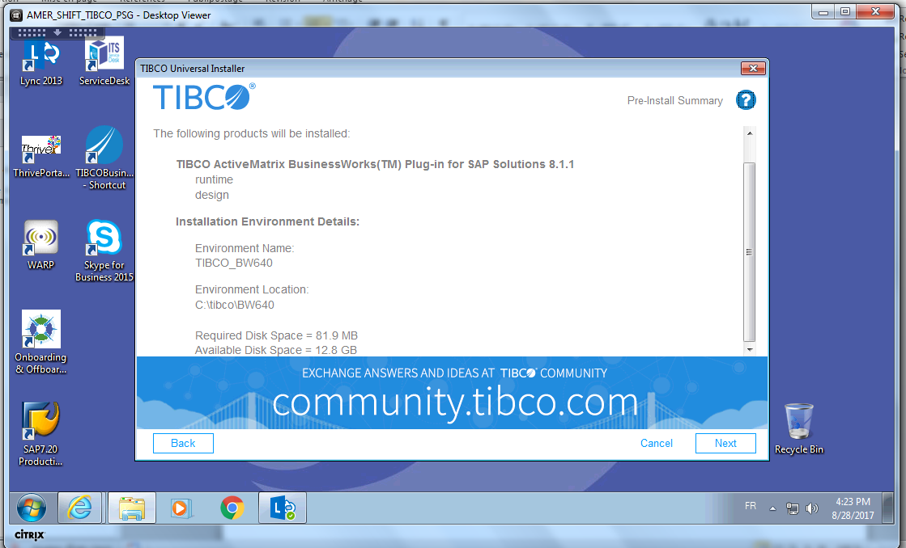

Post-installation Summary

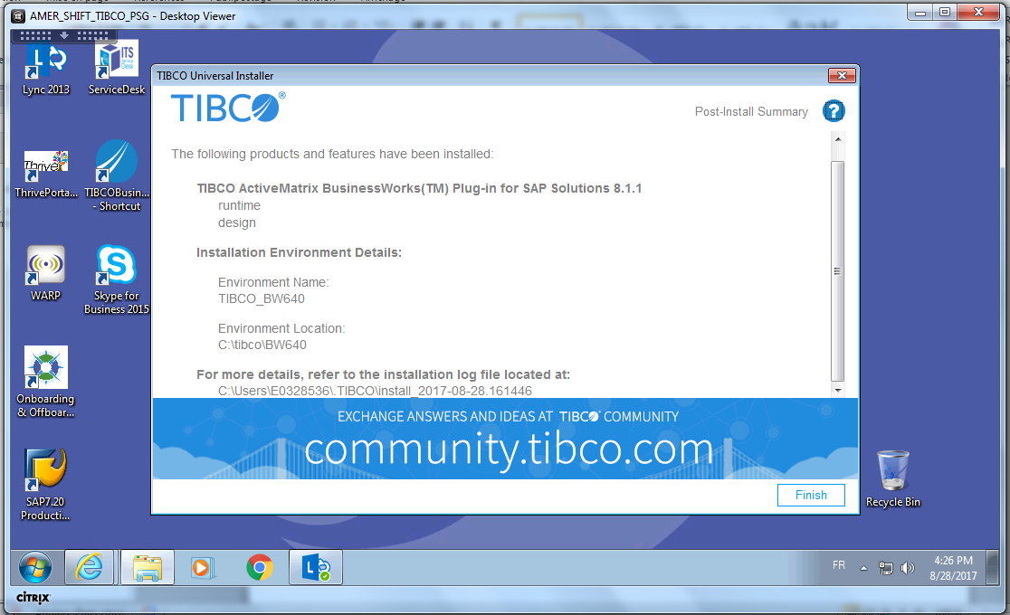

1. After the installation, you could get the following message:

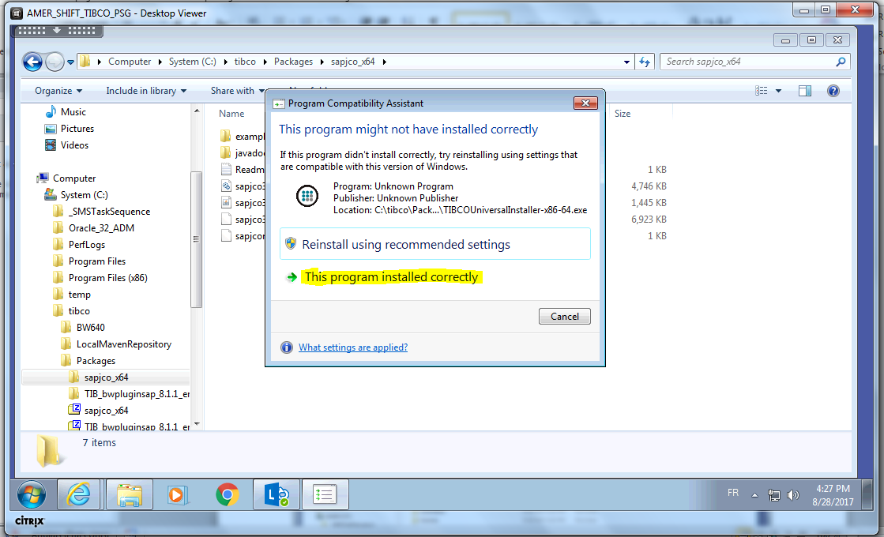

1. Click on This program installed correctly…
2. If you, to make space on the local disk, you can delete unzipped directories

**That’s all folks!!!**